E-commerce Platform Search Function implemenatation in JAVA

Algorithm Used: Binary search
Code explanation:-
- Create a Product class with Product ID, Product Name, and Category.
- Store product information in an array.
- Sort the array based on Product Name.
- Apply Binary Search to find a product.
- Display the product details if found.
Time Complexity:
- Linear Search: O(n)
- Binary Search: O(log n)

CODE:-
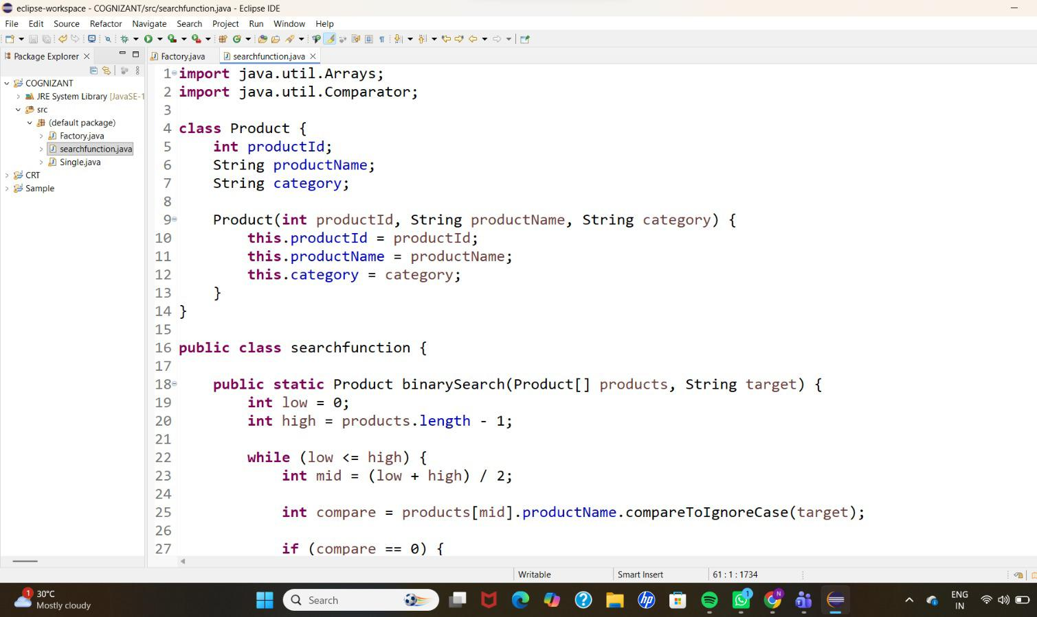
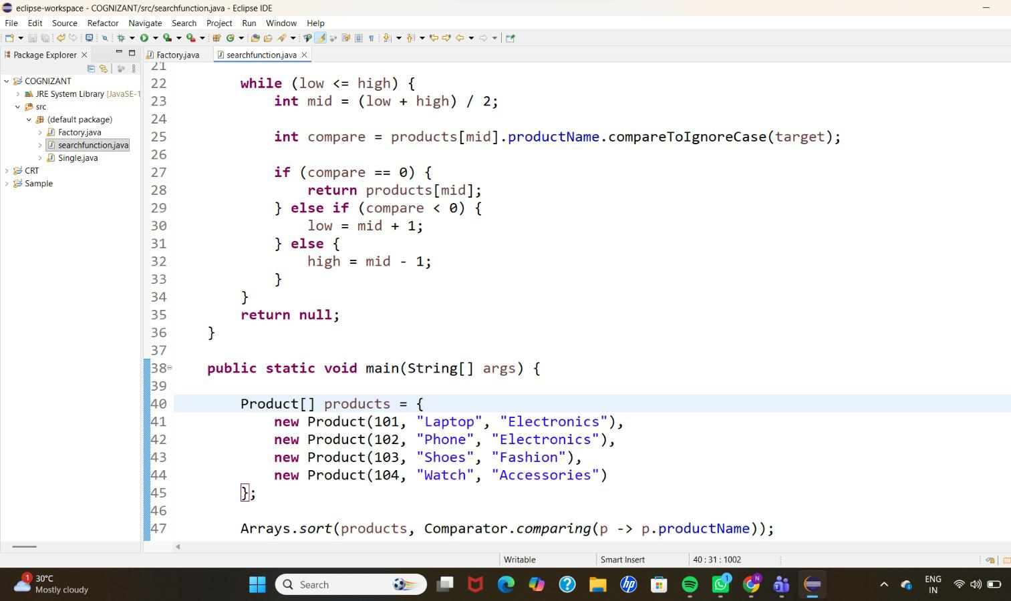
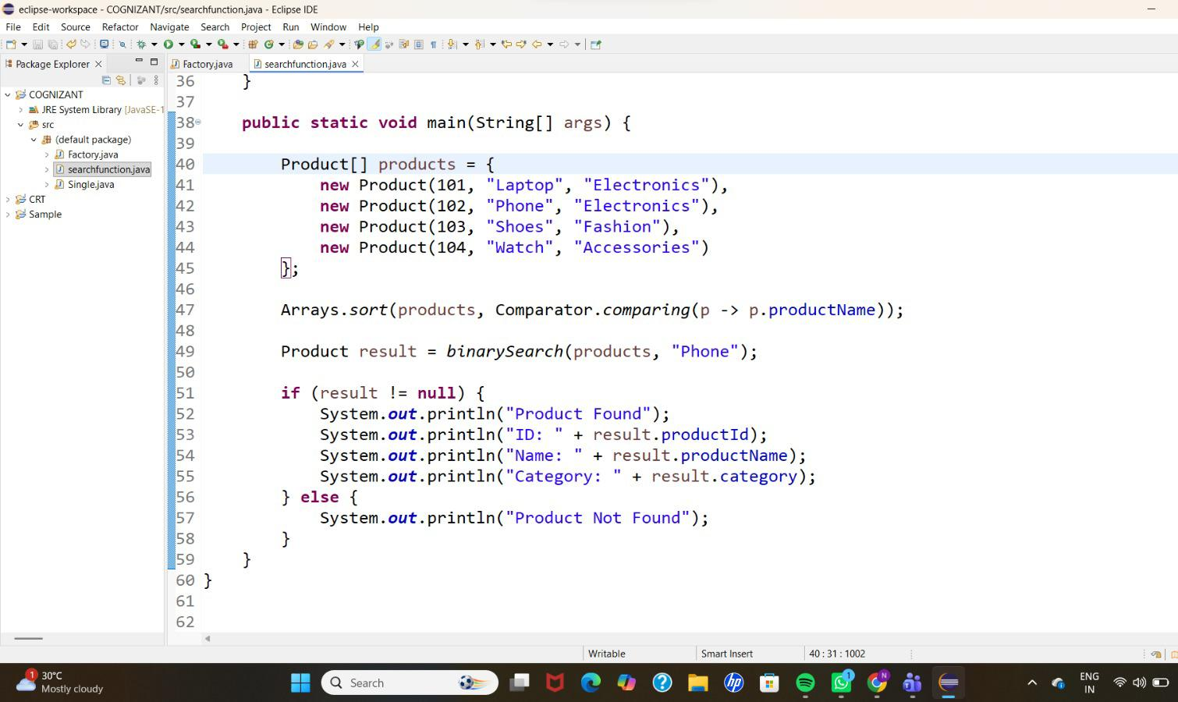
OUTPUT:-
